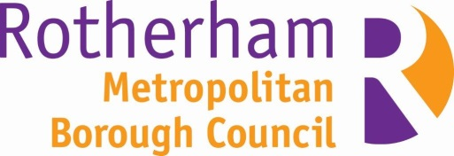

Men’s Mental Health - Small Grant Application Form

Group Details
Group information
Name of organisation or group:

Type of organisation -  delete those that don’t apply | Non-Profit Y/N  Community interest group Y/N  Registered Charity Y/N  Other ___________________________
Tell us briefly what your organisation does. | How often you meet, your aims and main activity, etc
When did your group/ organisation start?
Do you have the following?  -Constitution/ Terms of reference  - Public Liability Insurance  - Keeping vulnerable people safe (Safeguarding process and/or training) | Please attach a copy or send a link
Do you have any of these-  Website, social media account (ie Twitter or Facebook) | Please share any links
Bank details  Bank name, address and account details. | The bank account should be in the name of the organisation and have at least two people signing cheques
Any other relevant information you would like to tell us about your organisation
Contact Information
Name of main contact for the organisation
Role in organisation
Telephone
E-mail
Address and postcode

Please supply names of two referees | This should be people who know and can comment on the work your group does

Project Details
Project Title:

Project Description – please provide us with the background to your project. | You might want to consider these questions – please keep your reply to 500 words or less.  -What need is there and how will it address this?  -How have you involved local men in developing your ideas?  -What difference do you hope to make?  -How will you work with the local community?  -Is this a one off piece of work or will it continue after the funding?
What experience does your group have of working with men in this area and how will you use this experience?

When will the project begin/finish? | Start Date: | End Date:
How much funding will you be requesting? | £
Have you received any funding from other sources? | Yes / No  If yes describe
Total cost of the project? | £
Breakdown of what the funding will be spent on: | How the money will be spent |  | Amount
When will the money be spent by?
How will the money benefit your organisation?
Who will benefit from the project? | How many people, and how will they benefit?
How will you promote the project?
How will you evaluate your project? Please give us examples.
Please return this form to
Helen Wyatt, Patient and Public Engagement Manager Rotherham CCG, Oak House, Moorhead Way
Bramley, Rotherham S66 1YY helen.wyatt6@nhs.net 01709 302042

