**Ophthalmology Engagement August – September 2019**

**Survey completed in the Ophthalmology department at TRFT**

Concurrently, an email was sent to a number of community groups and organisations, outlining the proposal and offering a visit to discuss it. These included Rotherham Healthwatch, Rotherham Sight and Sound, carer organisations and older people’s organisations and groups. The CCG Engagement manager attended a number of carer and older people’s groups, and ensured that any questions were answered, generally there were no questions, and people were supportive of the proposal.

Sight and sound requested attendance at a coffee morning to discuss and share the proposal – an overview of this is attached at the end.

* **107** surveys completed; this was well over 200 contacts as many people were accompanied by one or more family members
  + This was over 2 days 13-14 august
  + Conversations took place in ophthalmology outpatients and B6; covering a variety of clinics
  + People from a wide variety of ages and background took part; we had no refusals, and spoke to the majority of people attending
  + The clinics were not as busy as usual, due to the time of year, in particular a number of the paediatric appointments DNA’d

**Views on the proposed move were generally positive**

* + **Generally, most people were very supportive of the proposal; a substantial number were extremely enthusiastic**
  + 59 felt it would be easier, 14 felt it would be harder; 30 were neutral; either they felt it would be the same or were unsure.
  + Those that felt it would be harder cited the following reasons
    - Longer journey
    - Parking was an issue for a large number of people
    - Not liking the town centre/road crossing/walk across town
    - One person felt there were issues with the building structure
    - They were familiar with the current service and location, and did not feel it needed to change – this in particular from those attending regularly, for years (ie monthly)
  + Those that were neutral
    - A majority of these felt there would be no difference
    - Some people were not familiar with the location of the CHC, so felt they did not know
  + From the patients attending B6 often on a monthly basis, there was more concern and apprehension about a change of location; often with no concrete reason (i.e. *‘I like it here’*). This may be due to the fact that these are likely to be the most dependent patients, who have become very familiar with the current location and process. This group of patients may benefit from additional support, information and assurance during the process

**What patients think about the department**

* + We felt that there were generally fairly low expectations around the environment*- ‘its OK as it is’ ‘ it’s a hospital isn’t it’.*  Generally, when we entered into a discussion with people, and talked about the waiting in the corridors, the size of the rooms, etc, there seemed to be an increased awareness that the environment could be substantially better
  + Although ‘friendly’ was not one of the original descriptor choices, this was added as so many people said this
  + People did find it hard to engage with the questions on the environment and the scaled questions were hard; with people confusing what happened to them to what they valued; we would phrase this differently another time

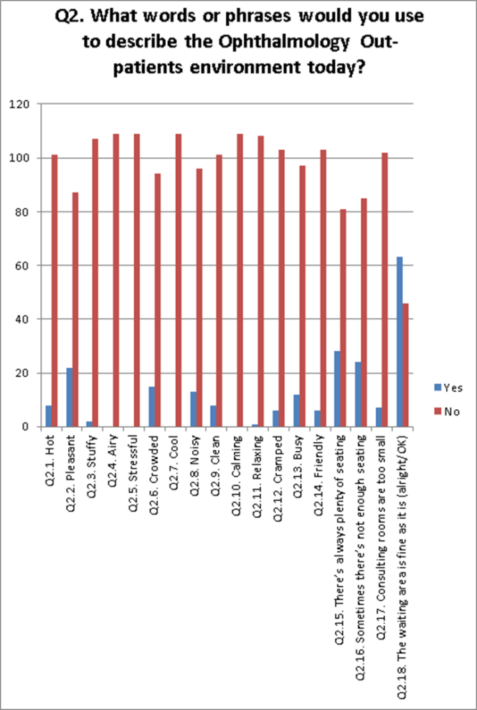

**Other points**

* + Although we had provided large print and people could fill in the surveys themselves, no-one wanted to, and were more than happy for us to scribe. If repeated, we would alter the template to make a survey easier for the scribe and not for self-completion
  + A number of people had seen the article in the advertiser, and assumed that the unit was moving regardless
  + The majority of concerns were around parking
  + A small number of people noted they live close to the hospital or on a bus route/road where they would pass the hospital, so it would be further for them
  + Several people wanted assurance that the staff would be the same
  + Even though the walk from car to unit would be shorter, some people will still need a wheelchair to be available
  + Other concerns raised were around traffic in the town centre, waiting for appointments and in clinic, not being called in
  + Several people asked how much it would cost; so assurance that we are spending the Rotherham pound well, and not being profligate will be well received.
  + It was also noted that patients are brought to ophthalmology from other areas of the hospital – those mentioned were neuro and the UECC. It was queried how this would work if the department was to move, how often this is needed, and what the impact could be on appointments if staff are called to TRFT site, or the implications for moving patients round the site. It may be useful to have numbers available as a response in case this is asked again.

**Sight and Sound   19.9.19   JH and HW**

Busy coffee morning –approx 30+ attendees; these included a variety of ages, and people registered blind, using guide dogs, some BSL users, and some with dual impairments

**Key points**

* Car park at CHC  felt to be busy, hard to park now
  + Noted that staff will be moved out to alternative parking
* Some felt that the access and environment at TRFT was poor; one had chosen to access services at Sheffield because of this
  + The CHC would give more space, bigger and more consulting rooms; and may help to reduce wait for appointments
  + A number of people acknowledged that they already access CHC for audiology services
  + The move would give space for wheelchairs and buggies
* For some bus users, it would be difficult, as there is no bus to CHC, and it was felt to be a long distance
  + Noted that for those eligible, medicar could be requested; James will work with S&S to make sure information gets out to be people about this
  + Some people were reluctant to use the crossing on the dual carriageway
  + Some thought it would be hard for those with limited mobility or no sight
  + No buzzer on the crossing
* Query if there are staff shortages at TRFT
  + Relatively stable, but staffing is an issue everywhere, and patient numbers are increasing
* Why are clinics cancelled
  + Try not to, but sometimes unavoidable due to illness, and needing cover
* Contact centre – several people mentioned difficulties in getting forward appointments, and having to chase appointments themselves – some people might forget
* Automated check ins at TRFT and GPs not useable for people with VI, there has to be an alternative
* Query – will the centre be open weekends
  + TRFT are looking into this, but not definite
  + Concerns about access to services , as felt that sight had been impaired by waiting to see someone over the weekend
* Noted that S&S over training to medical students at STH  - **can we look into this?**
* **S&S to liaise with JH over possible future links and presence/space  for materials when unit moves**
* **JH to keep in touch with updates and information as project progresses**
* **Noted that staff often say to people ‘follow me’ – if you are blind this is hard!  Is there a way of noting something on patient records, and staff and patients working together, to look at how this could be improved, especially for those with no sight**

Following the meeting, JH and HW walked from the bus station to the CHC, following noted

* There are two walking routes; one towards Tesco, and alternatively, past chapel on the bridge, the pub and the trades club
* Cheap parking noted attached to the trades club
* No buzzer on crossing – can this be looked /changed?  JH?
* Could we look at additional warning signs on the road?  Who can advise on this?
  + Would it be worth doing the walk with people with VI to look at anything else that could be done to improve access?