- Go to APPOINTMENTS, REMOTE BOOKING

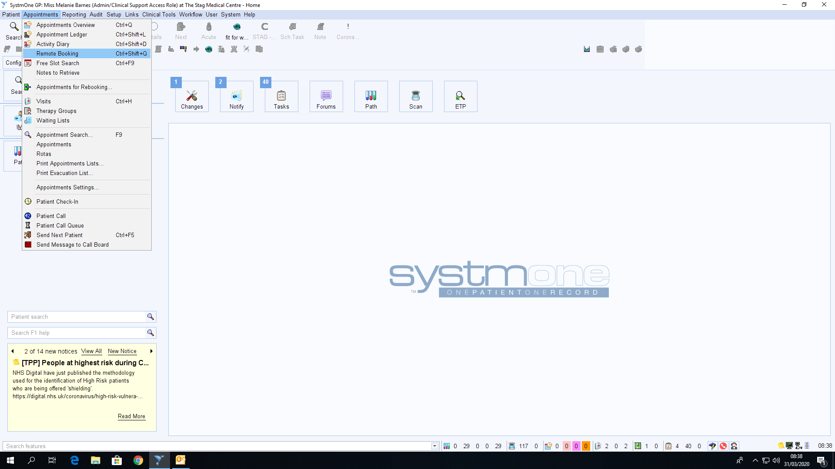

- Below is the remote booking screen, from the drop down box that says SHOW ROTAS FOR, select ROTHERHAM HUB SERVICES, the second drop down box that says ROTA TYPE, select GP

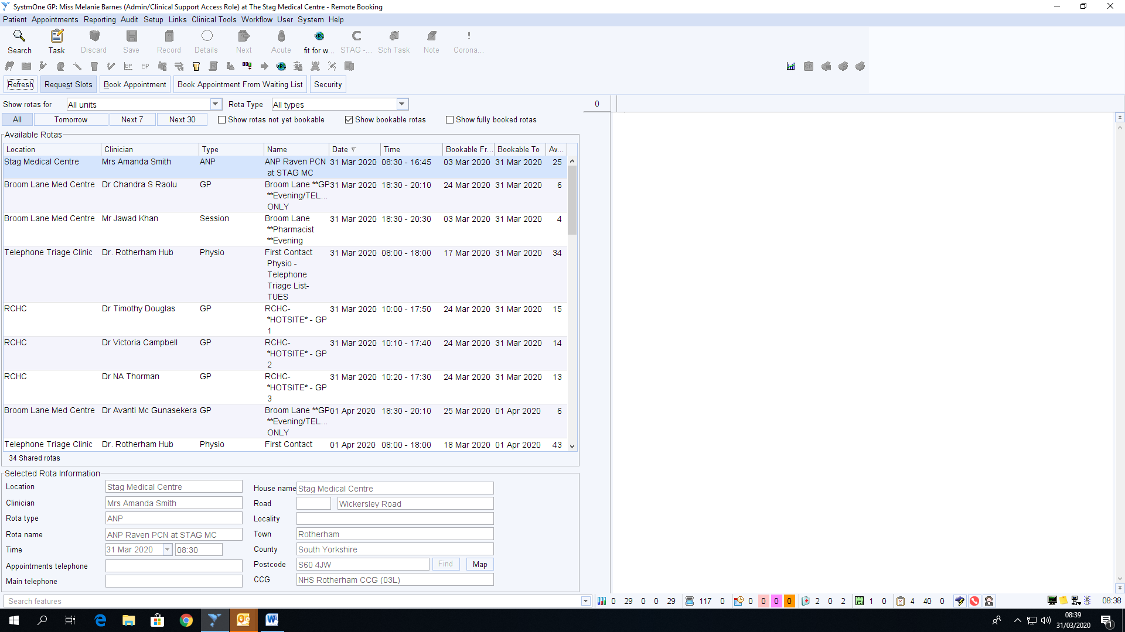
- When you have selected ROTHERHAM HUB SERVICES and GP ROTA TYPE, the rota’s you will be booking into are called RCHC, HOTSITE 1, 2 and 3, these will appear on the LEFT hand side of the screen (IF THE ROTAS ARE GREYED OUT YOU WILL HAVE TO LOG OFF SYSTMONE AND LOG BACK ON TO SEE THEM)
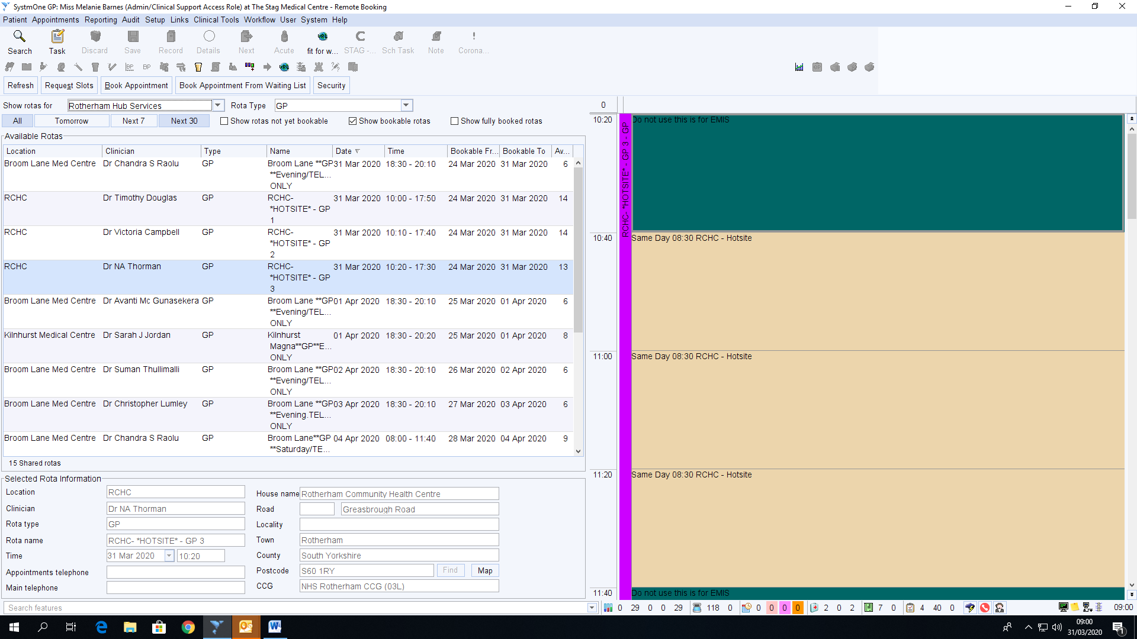

- When you can see the Rotas, highlight which one you want to book into and click on REQUEST SLOTS
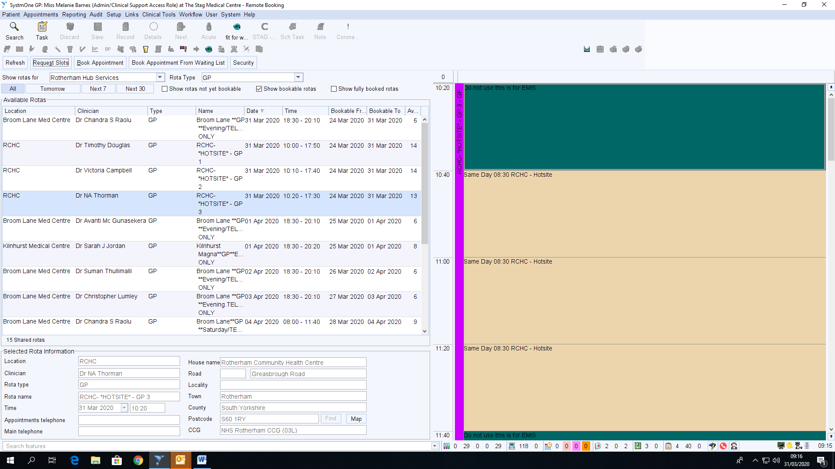

- RIGHT CLICK on the appointment you want, and select BOOK APPOINTMENT

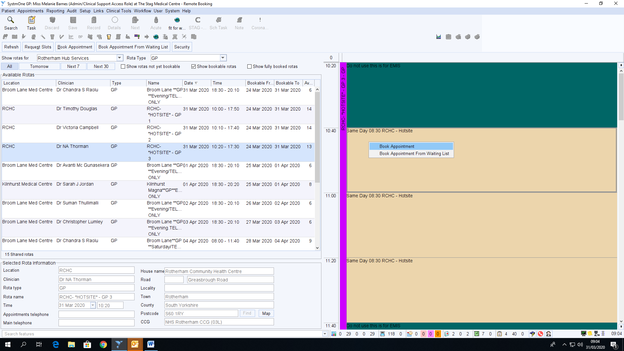

- The patient search box should appear, search for patient you are booking the appointment for, select the patient,
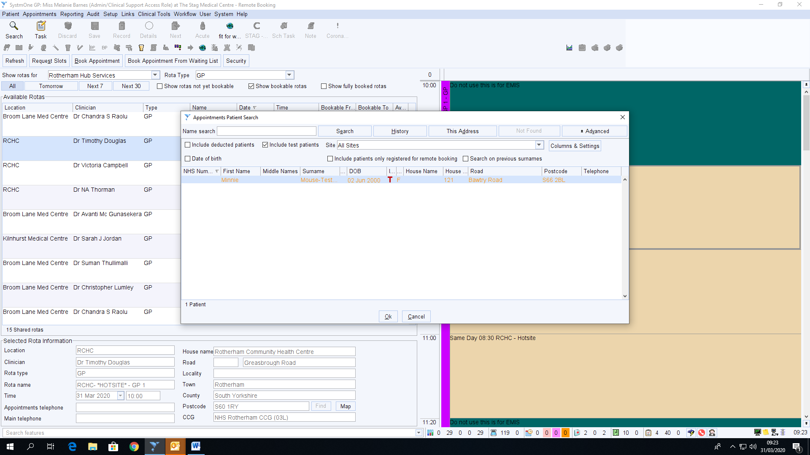

- Once selected the patient, the APPOINTMENT BOX will appear for you to complete, Please ensure you complete information/symptoms about the patient in the DETAILS BOX
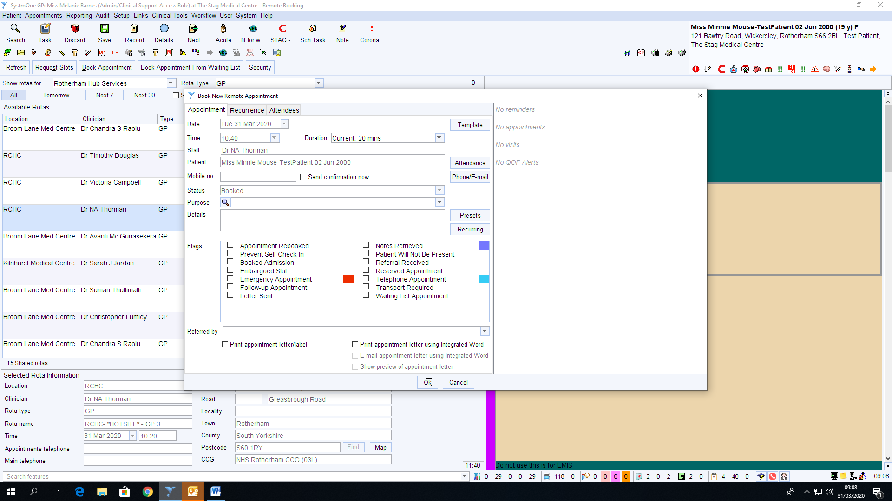

- EACH TIME YOU WANT TO BOOK A NEW APPOINTMENT YOU WILL HAVE TO HIGHLIGHT THE ROTA YOU WANT AND CLICK REQUEST SLOTS

