How to add Covid-19 Assessment Template onto Clinical Tree under Organisation Preferences
- Go to Setup
- User & Policy
- Organisation Preferences
- Clinical Policy
- Clinical Tree configuration
- Highlight the Practices clinical tree in middle column, and click on Amend
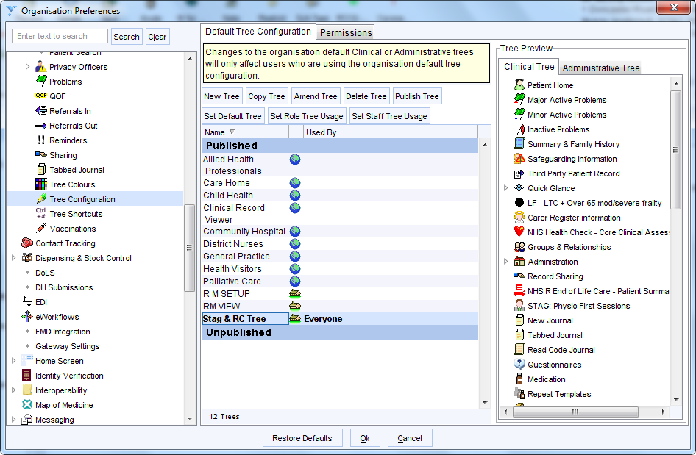

- Type in covid in the search panel
- The Covid-19 Assessment template will show below the search bar
- Highlight on the left side of the screen exactly where you want to template to be in your clinical tree, the either double-click the mouse or use the arrow to add the template to your clinical tree.
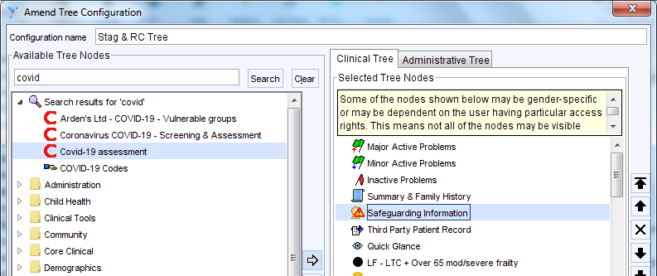
- Once complete click ok, then ok again to come out of organisation preferences.
- When you then go into the next patient you will see the template on your clinical tree.
If you are not on the Organisation Clinical Tree, then you will not see the template. To add it onto your own clinical tree, do the following:
- Right click anywhere on the clinical tree in patient record
- Choose Customise Tree
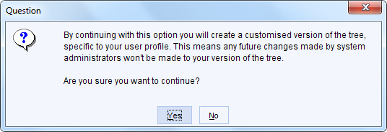
- You will see the message above. Click Yes
- Highlight on the left side of the screen exactly where you want to template to be in your clinical tree, the either double-click the mouse or use the arrow to add the template to your clinical tree.
- Once complete click ok to come out of the Amend Tree Configuration.

How to set up a template in your Favourite Screen
  - To set up the template within your Favourite Screen, press F12 on the keyboard. This will show your Favourite Screen. Type ‘covid’ in the search bar and press return. The Covid-19 assessment template will appear on the right-hand side.
  - Click on the template name with your left mouse and drag across to the left-hand side of the Favourites Screen (you can add this to any letter).
  - To open the template, double click on the template name on left-hand side of screen.
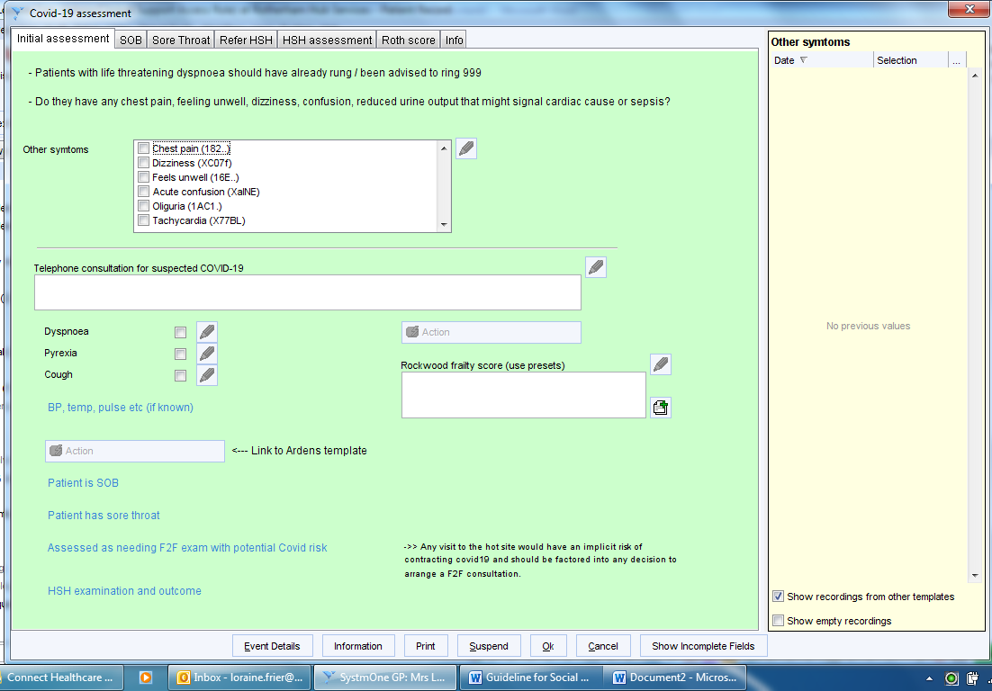
  - To use the template again for the next patient, just press the F12 button, and follow the instructions as above by double clicking on the template name on the left hand side of the screen.

