Lucy, 92
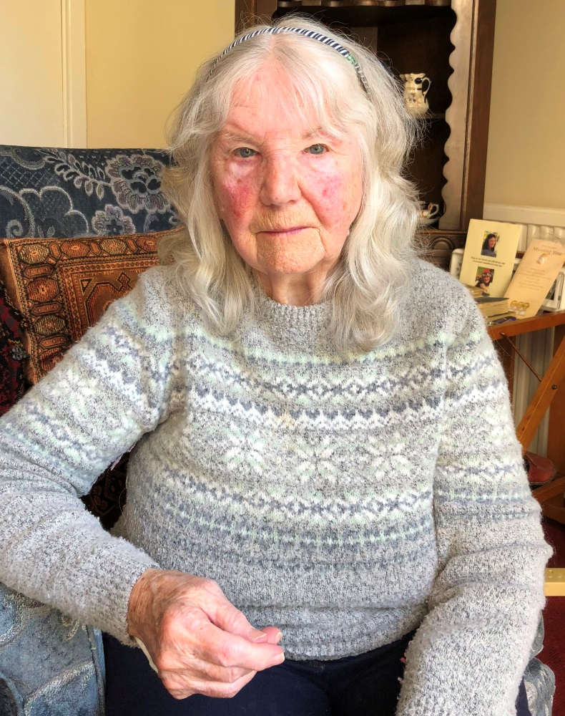
I remember Dr Johnson our doctor – he was lovely and like a “granddad” to all the children. When I was about 8 I went into Wathwood Hospital with a fever. I should only have been there for two weeks and was there for 14 weeks because I deteriorated. My family could only see me through a glass window. A friend of the family worked at the hospital and she told my dad that he needed to get me sorted out because I was in a bad way.
My mum told my dad that she was going to get me home and she did.

The hospital van brought me home from hospital and the driver said to my mum “I’ve brought your daughter home”. My mum replied – that’s not my daughter it’s a bag of skin and bones.

I remember I wasn’t eating at all in hospital and from then on my mum was determined to fatten me back up and she did. I remember the first thing I ate was pickled cauliflower and I couldn’t get enough of it !!

From the minute I went home I never looked back and went from strength to strength. I remember a doctor visited me every day and he was really nice – he had to massage my legs to make sure that I kept moving. My dad borrowed a pushchair and would take me out along the towpath to visit relatives.

