Eva Firth
Eva is 93 years young, and worked as a district nurse in Swinton and the surrounding areas for almost all of her working life.
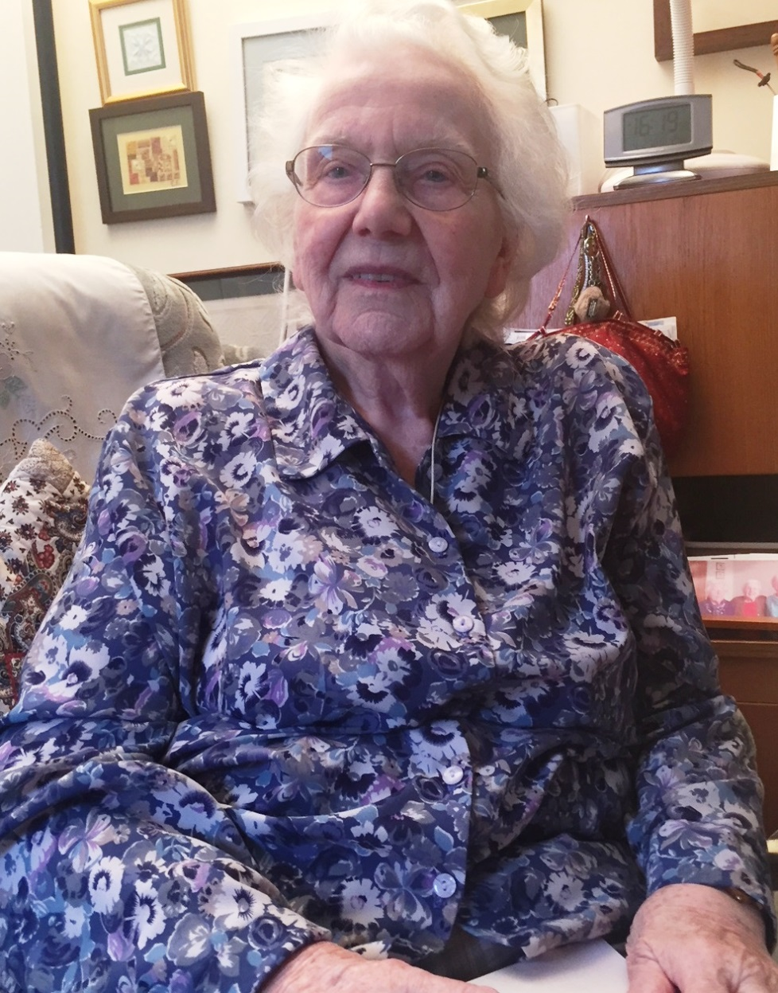
Born in 1924, Eva qualified during the first year of the NHS at Sunderland General Hospital. She married Harry Firth shortly before qualifying in 1947, and was the only married nurse in Sunderland General Hospital, having to ask permission to finish her training. When her husband left the Navy and started work for the coal board, the couple moved to Brampton in South Yorkshire, with Eva first working at Kendray Fever Hospital for around a year. She then took up her post in Swinton on the 1st November 1949, working for the West Riding Health Authority, under the senior nurse, Miss Greenwood.
The District Nursing Services in Swinton were based in the ‘Nurses Home’, a large building that is now a private house, where Eva’s colleague Lynn lived, to Eva, Lynn seemed very old - she was in fact 35.
Eva remembers in great detail her rounds and patients; she covered half of Swinton and Kilnhurst village, and can recite the order of calls and the often convoluted transport arrangements. During the 1940’s and 50’s, rounds were completed on foot, so calls were often managed to fit in with bus times.
Finding a large, old bike in an outhouse was a bonus; her husband repaired the bike, but Eva, who is very petite, struggled to get on the bike unless there was a handy kerb. In addition, Eva’s route was very hilly, so the bike often had to be pushed. People looked out for the nurses though, and she would often be given a lift by a passing ‘coal wagon’ or the local dustbin lorry; her bike fastened to the back!
Travelling was made worse by the bag of equipment that had to be carried everywhere, including a small milk pan which was used to boil syringes for injections; this often had to be done on open fires. Nurses at the time had few of the resources available to nurses today; antibiotics in the form of penicillin came out while Eva was training. However it wasn’t as straightforward as now, it had to be drawn out of a bottle and injected via a glass syringe boiled in the milk pan. The nurses always carried adrenaline, as anaphylactic shock from penicillin was known to be a danger, and Eva did have to use this on one occasion; this was a rarity, and very few had to resort to this.
The ‘DIY’ approach to equipment didn’t end with sterilising syringes; the staff had to also sterilise dressings. The materials were cut into appropriate sections, relevant to the patient list, packed into a tin, and baked. When dressings started to be supplied centrally, Eva felt that it was ‘a godsend’; however she was also concerned that so many were provided, with so much waste, that someone must have been getting rich from this new system!
The nurses referred to a number of their patients as ‘poorlies’; one example was a couple in their 70’s who were both ill with flu and pneumonia, they were deemed very elderly at the time! When the husband was admitted to hospital, Eva was able to organise home care of 3 hours, three times a week - with our modern perspective, this seems astonishing. The ‘poorlies’ would always get two visits a day from the nurses. Cancer was nursed at home unless people were very ill, with at least two or three daily calls; the nurses would call on very ill patients whenever they passed the house. There would often be a sigh of relief when the nurse walked in, and people could pass the responsibility over for a brief while.
Eva is able to open for us a window on a very different world of health and care. There were old people to wash and dress and get up, and dressings to change. There was a young man that had a visit every day for 15 years, he had spent time on a ‘plaster bed’ while in hospital, and was very stiff, and he had to be washed and turned and made comfortable.
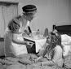
Drug therapies and surgeries were far more limited, and the expectations of the public extremely low compared to now. Eva vividly recalls her patients; many were diabetic, which at the time was a very scary condition. Insulin injections were given by the nurse, and just occasionally a family member would be trained to do the injections. Eva recalls diabetes as being an ‘awful business’, again syringes were manually boiled and filled, and a Bunsen burner used for testing urine.
There were night visits, often to administer ‘morphia’ to people in pain; these sometimes had to be done on the bus, though this improved when Eva’s husband was able to take her on the back of his motorbike! It was even easier when Eva passed her driving test age 40, and got her own car; from this point she then was able to travel 7 miles a day, and was also able to cover for neighbouring areas, such as Wentworth.
There were other challenges than transport; the staff had to go out on foot, bus or bike, regardless of the weather, and ‘you worked as long as you had to, and were needed by patients’. Patients with infectious diseases were a challenge, ‘you took your coat off outside the door, and went in gowned and gloved and masked, the gloves were awful ‘. When Eva expressed concern that she could pass infection on to her next patient, she was told “well you are walking, so you will disinfect yourself.’ Also in some houses, a sheet of the daily newspaper was the cleanest place for the nurses’ bag and equipment to go!
In particular, Eva really didn’t like some of the other requests that the nurses would get, such as opening things and judging baby shows - how could you choose one baby over another? She didn’t feel comfortable with a regular request to nominate local ‘deserving poor’ to receive a bag of food items at Christmas each year. This was a holdover from the days of a local charitable fund, and lasted into the 1960’s. Notably, people with diabetes got a parcel each year, diabetes was seen as such an issue at the time.
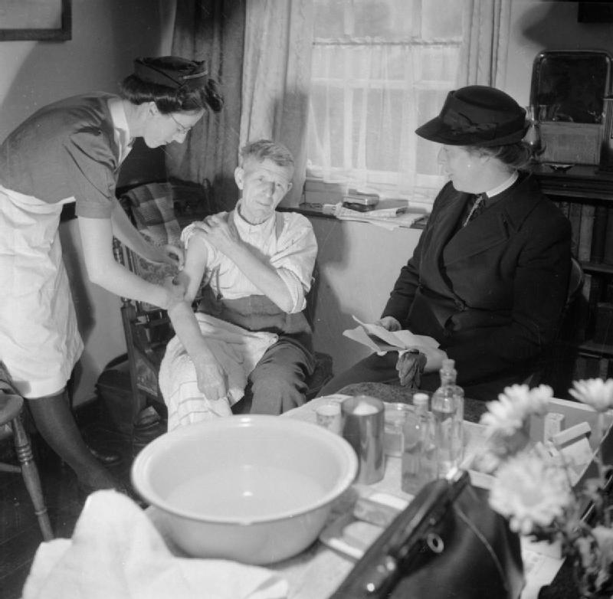
Eva remembers when Social Services departments were first created, and her dealings with the staff- at that point, there was no training for social workers; that came later. The clerks from the office became visiting social workers overnight, and did not always bring a lot of life experience to the role. Ensuring that the vast knowledge and experience of the district nurses was acknowledged and acted on was a challenge!
But there were many things that Eva feels were incredibly positive in those early days of the NHS.
The health staff were a true part of the community; Eva knew all her patients and their families, through several generations; in her own words, ‘you nursed them, their mothers and their grandmothers’. Eva recalls visiting one lady three times a week, and seeing her granddaughter grow up, get married and die, leaving two young children. The doctor knew everyone and visited everyone, and was very much trusted. People would stop the nurses and tell them if someone wasn’t well– the nurses would then call in and check this out, and in the same way would raise concerns about children with the local health visitor.
People stayed in hospital for a lot longer, and were often admitted on the direction of the nurse or the GP, ‘If the nurse or doctor said you needed to go in, you went’. Although now, people return home much sooner, this can be scary and isolating for someone living alone, especially with increasingly limited support in people’s homes. Eva was herself ill early in 2018, and felt very much alone, as she lives in a sheltered but independent housing complex.
********
Eva feels that people’s attitudes have changed over the years, and that people now expect more; while those of her generation didn’t expect much. People went into nursing because they wanted to, not for the money.
Eva has always worked with two pieces of advice in mind. These came from her first lecture in district nurse training, one being that the nurse is a guest in the patients’ house, and should behave accordingly. The second was about the three attributes that any nurse should have; they should be intelligent, articulate, and should know their own worth. Eva feels that these are still relevant to anyone in similar professions today, and has passed these on many times.
In addition, Eva has a few thoughts about the world in general, and tells us this;-
‘If I ruled the world, I’d ban ear phones in both ears, so that people took notice of the world round them, and I’d get rid of ‘Health and Safety’, and would bring back good manners and common sense’

